Word Scramble–

Communication Protocols

Overview
The distributed application our group is building will be a two-player game called Word Scramble. It will largely be based off the board game Scrabble but will have some key differences in game play. Each player will be given an allotted number of letters and will take turns spelling out words on a 16 x 16 tile game board. When a player places a word on the board, that word is checked against a dictionary of valid words. If the word is valid, then the turn is passed to the other player. There is no restriction on where a new word can be played on the game board. Play continues until the game board is filled and no new words can be played. The player with the least number of remaining letters is the winner.

Table 1 – Protocol List

Purpose | Initiator | Other Processes | Pattern
Authentication | Client | Database Server | Idempotent Retry
User Creation | Client | Database Server | Idempotent Retry
Register Referee | Referee Server | Database Server | Idempotent Retry
New Game | Client | Referee Server | Idempotent Retry
Game Update | Client | Referee Server | Proxy
Heartbeat | Referee | Client  Database Server | Request- Reply

Messages and Shared Objects
We will have three shared Resources. The first shared resource is the Game Object. The game object will be used by the Game Update protocol, and it will live in the referee Server. The game object will be shared by TCP/IP connection to two clients. The information in the Update Game message will come from the Game Object, and the send move will send the potential word, and location for the new word. The second shared resource will be the Dictionary Database. The Dictionary Database query will be created using the Check Word message and will respond to the referee server with the Check Return value. The final shared resource will be the XML Registry. This file will live in the Database Server. The information will come from the Server Information message. The Server Database will send an Acknowledge message and will trigger the Referee Server to send Heartbeat Messages. The information in this registry will be sent to the clients after authenticating. The message will be repeated until an Acknowledge is sent from the client to the Server Database,

Message | Format
Login | Message Type=1  Register: short integer  Username: string  Password: string
Login Accepted | Message Type=2  Accepted: bool  Error: string
Create Account | Message Type=3  Username: string  Password: string  Security Question 1: string  Security Question 2: string  Security Answer 1: string  Security Answer 2: string
Account Approved | Message Type=4  Accepted: bool  Error: string
Server Information | Message Type=5  Server Type: short integer  IP: string  Port: unsigned integer
New Game Request | Message Type=6  IP: string  Port: unsigned integer  Username: string
New Game Acknowledge | Message Type=7  Queued: bool
Send Move | Message Type=8  Game Id: Short  Username: String  Word: String  For every char in Word  Letter position x: short integer  Letter position y: short integer
Update Board | Message Type=9  Game id: short integer  Tiles: char [16][16]  Word passed: short integer  Client Username: string  Client tiles remaining: short integer  Client Score: short integer  Opponent Username: string  Opponent tiles remaining: short integer  Opponent Score: short int  Player’s turn: bool
Check Word | Message Type=10  Game ID: short integer  Word: string
Check Return | Message Type=11  Game ID: short integer  Valid: bool
Quit Match | Message Type=12: Short  Game id: Short
Heartbeat | Message Type=13
Ack | Message Type=14  Message type acknowledged: short integer

Communication Patterns
Our system is using three communication patterns, Idempotent Retry, Proxy, and Receive-Reply.

- Idempotent Retry
Authentication, User Creation, Register Referee, and New Game protocol all use this pattern Idea in its implementation. The Idea behind this pattern is the initiator send a message to a location. If the location does not respond back with an acknowledge within a certain amount of time the initiator assumes the packet was lost and resends the message again.
- Proxy
The second pattern are design will use is Proxy. This is done inside the Game Update Protocol. The Player sends a word using the Send Move message. The Referee Server now sends the word to the back-end database server. The back-end server performs a query on the word and sends a reply to the Referee Server. If the word is a valid word it will add it to the game board and send the updated game to both players.

- Receive-Reply
The final pattern we use is the Receive-Reply pattern. The Heartbeat protocol will use this pattern. The User Client, and the Database will receive a heartbeat message from the Referee Server. They will then immediately reply to the Heartbeat Message. This protocol will be asynchronous of the other Messaging Protocols.

Communication Protocols
(Describe each protocol list in Section 1, including the allowed message sequences, semantics, and expected process behaviors)
- Authentication
The Authentication protocol will be UDP and initiated by the
User Client. The User Client will capture the username, and password f the user. It will then send Login message to Database Server. It will wait 15 ms for a Login Accepted message to return. If it is not received it will send Another Login Message. The Database Server will respond to a received message by grabbing the username, and password and performing a query on the User Database. If it is a user it will respond with a Login Accepted message where Accepted is set to true, and it will grab a Referee IP from the registry, and send a Server Information message every 15 ms, until 30 seconds elapses, or The Server receives an Acknowledge message from the User Client. If the Login Failed, the error portion will be filled with a string and the value of Accepted will be false.
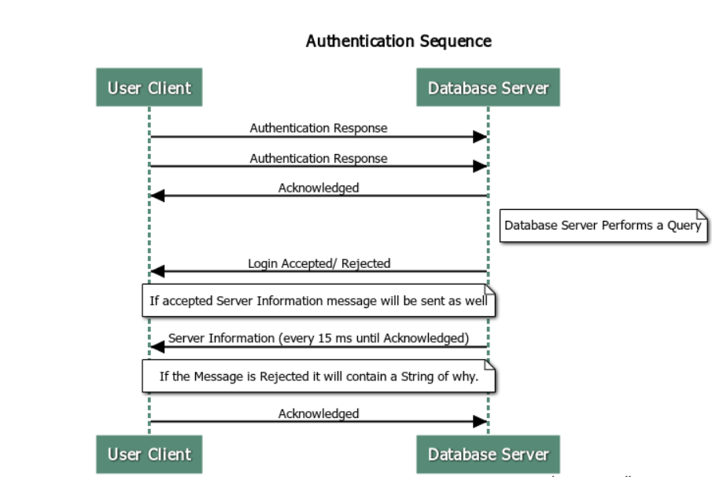

- User Creation
User Creation message will be initiated by the User Client and will be a UDP Protocol. The User Client will capture the username, password, and two security questions. The Client will then package them into a Create Account Message and send it to the Database Server every 15 ms until it receives an Acknowledge Message. The Database Server will perform a query to verify account doesn’t already exist. If the account already exists it will send back an Account Approved message with the Accepted value set to false, and a string in the error portion of the message every 15 ms until it receives a response from the User Client. If the user does not exist. It the Database Server will add it into the User database and send an Approved Account message with Accepted set to true every 15 ms until it receives an Acknowledge Message from the User Client. The User will now be able to login.

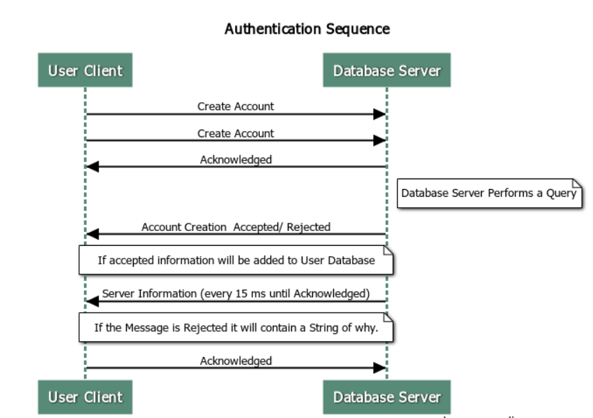

- Register Referee
The Register Referee Protocol will be a UDP protocol and will be initiated by the Referee Server. The Referee Server will send its IP address and TCP Port number for User Clients to use. The Referee Server will send a Server Information Message to the Database Server every 15 ms until it receives an Acknowledge. When the Database Server receives the Server Message it will add it to the XML Registry.

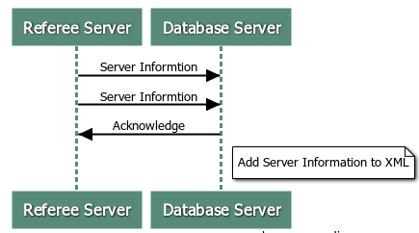
- New Game
The New Game Protocol will be a UDP and it will be initiated by a User Client. The User Client will send a New Game Message that contains the User Clients IP Address, port, and string every 15 ms until the Referee Server sends an Acknowledgement. When the Referee Server receives this information, it will create a player object and add it to a FIFO queue.
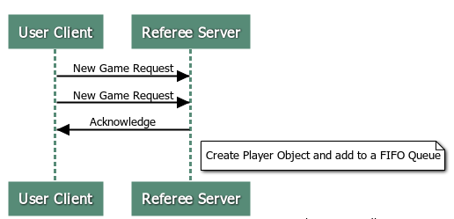

- Game Update
The Game Update will be a CP Protocol and is the more complicated of the Protocols. The Game Update Protocol will be initiated by the referee Server. When there are two players in the queue, they will be placed into a game object and sent a game update message. The First Player will send a word in a Send Move Message, and the Referee Server will forward the word to the Database Server inside a check word message. The Database Server will determine the Words validity and respond with a Check Return Message. If the Word is valid the Referee Server will update the board and send an Update Board Message to both players. This will contain the char[16][16] array, Player Score, and who’s turn it is. Player 2 will repeat the process. This loop will continue until a connection is interrupted, a Quit Game Message is Received, The Board runs out of spaces, or a Player runs out of letters. If the word is invalid the Referee will submit the current board but will change player turns.

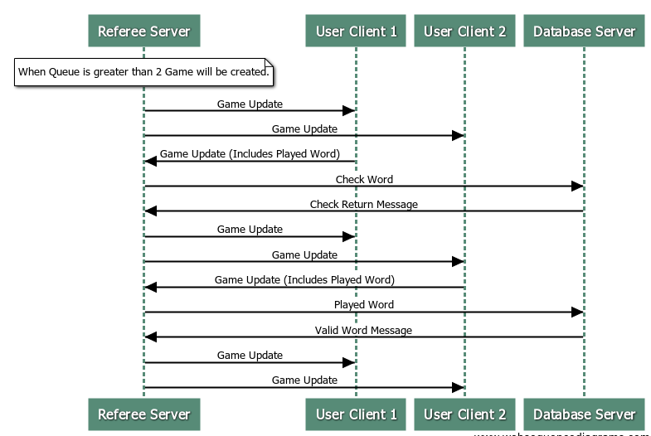

- Heartbeat
The Heartbeat protocol will be asynchronous, UDP, and will be initiated by the Referee Server. Every 5 ms the Referee Server will send a heartbeat to all User Clients, and the Database Server. If a response is not received after 30 ms the Referee server will either end a User Clients connection, and end the game, or it will pause all games and send 10 heartbeats to the Database server spaced every 30 ms. If the Database server doesn’t respond the Referee Server will close all games and shut down.

